1. Go to **CITI Program** website at [**www.citiprogram.org**](http://www.citiprogram.org/)
2. Select "**Log in**”

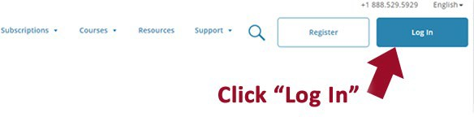

1. Choose “**LOG IN THROUGH MY INSTITUTION**”

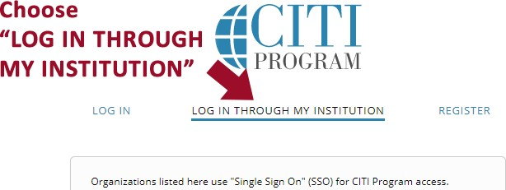

1. Enter "**Arizona State University**" and select it under the list of organization names
2. After logging in, select “**I don’t have a CITI Program account**” unless you already have a CITI account or had a CITI account through another institution. CITI Program is a free of charge service.
3. You will need to agree to some terms. Once you agree, select **"Create a CITI Program Account"**

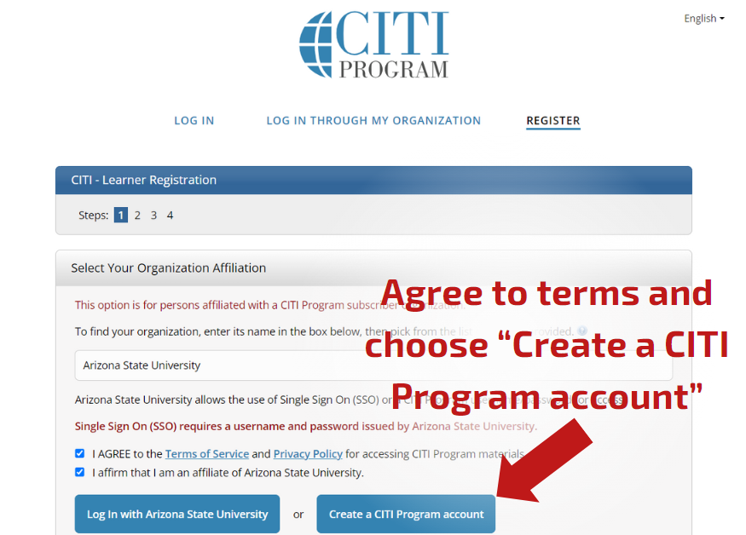

7.Follow the on-screen instructions to complete the registration process. When prompted for "**ASURITE**", type in **NOASURITE**".

8. Continue with the registration. You will be prompted to enter the name of your research department, role, and research sponsor. If you have no sponsor, then type in **"none"**.

9.Follow the on-screen instructions

10.After logging in, View Courses for “**Arizona State University**”. This screen will show you your Active Courses, Courses Ready to Begin, and Completed Courses.

11.To add a new course, scroll to the bottom of the page “Learner Tools” and select “**Add a Course**”:

12.You will be directed to the “Select Curriculum” page. Scroll down and check the box next to the course or courses you need:

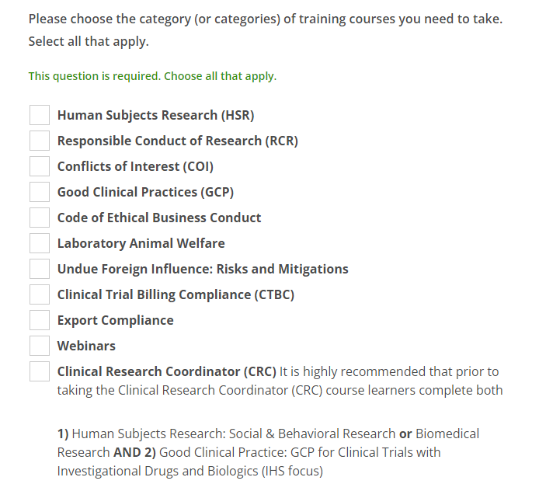

13.Scroll to the bottom and click “Next”.

14. Select specific courses from those listed and click "Next". If Conflict of Interest, Code of Ethical Business Conduct, Undue Foreign Influence: Risks and Mitigations, or Export Compliance is selected for Step 11, you will automatically be enrolled in the course.

15.You will receive a message:

16. On the Active Courses page, under “Courses Ready to Begin”, click on “Start Now” for the course. Complete the required modules and the quiz.

17.After completing the course and passing the quiz, Select “View Post-Course Completion Options” and “Access your Completion Records”. “View/Print” your completion certificate and save it for your records.